6.6 The gradient of a line B

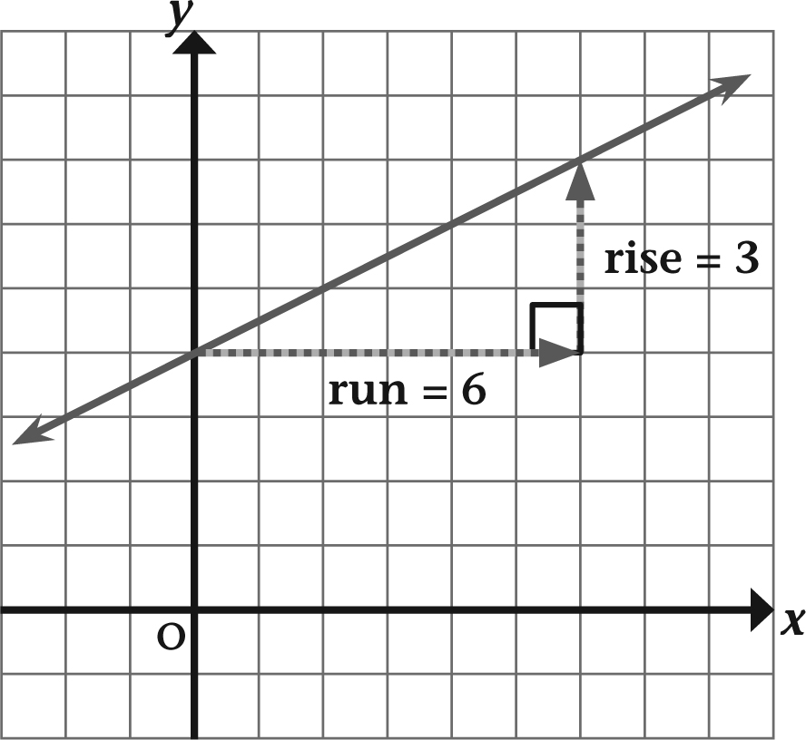
The gradient is calculated using the rule:
GRADIENT = | VERTICAL RISE
GRADIENT = | HORIZONTAL RUN
In this diagram:
Gradient = | Vertical rise
Gradient = | Horizontal run
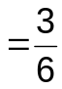
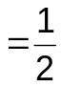
We usually leave the answer as a fraction.
The gradient is positive because the line slopes up to the right.
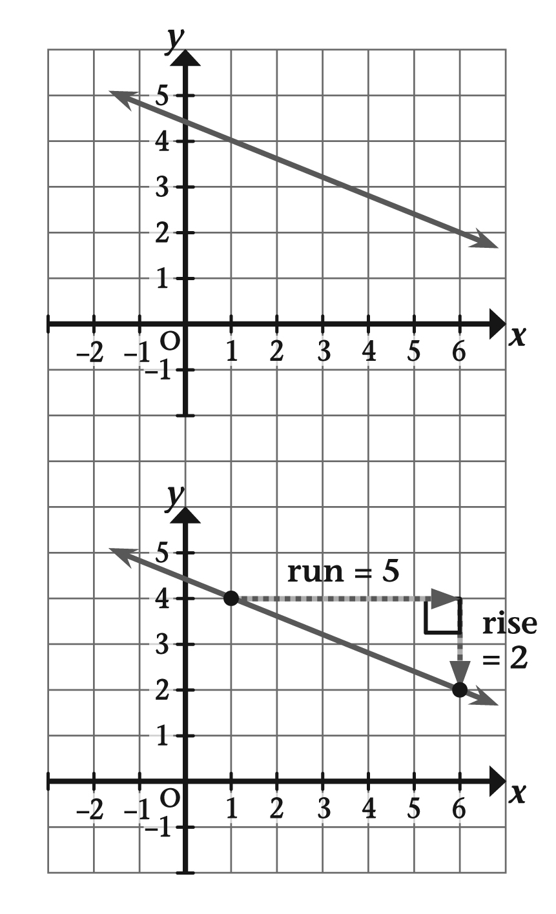
Calculate the gradient of this line.
Steps to follow
•Pick two points on the grid.
•Using grid lines, draw the right-angled
triangle joining these two points.
•Count the rise and the run.
•Calculate the gradient.

Gradient =Vertical riseHorizontal run
The gradient is negative because
the line slopes down to the right.
EXAMPLES

6.6 The gradient of a line B
continued
1 Calculate the gradient of each line.
Give your answer as a fraction in its simplest form.
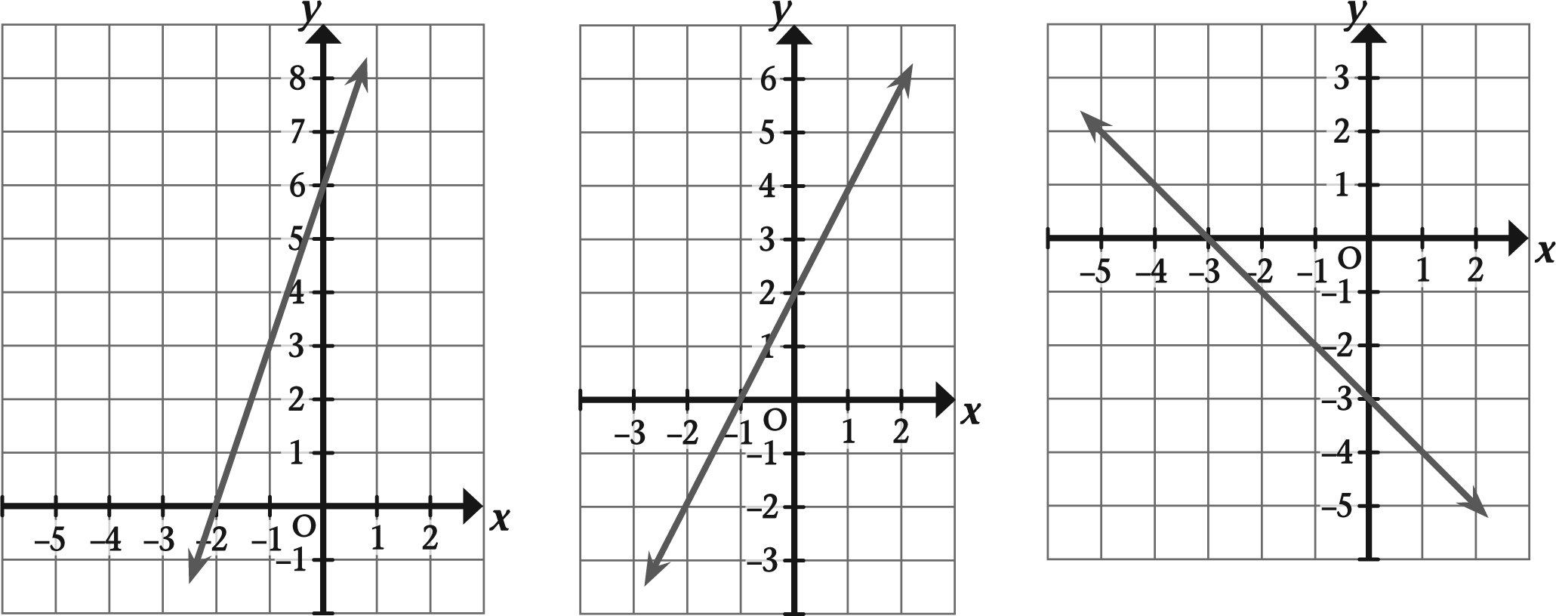
a b c

Gradient = _________ Gradient = ________ Gradient = _________
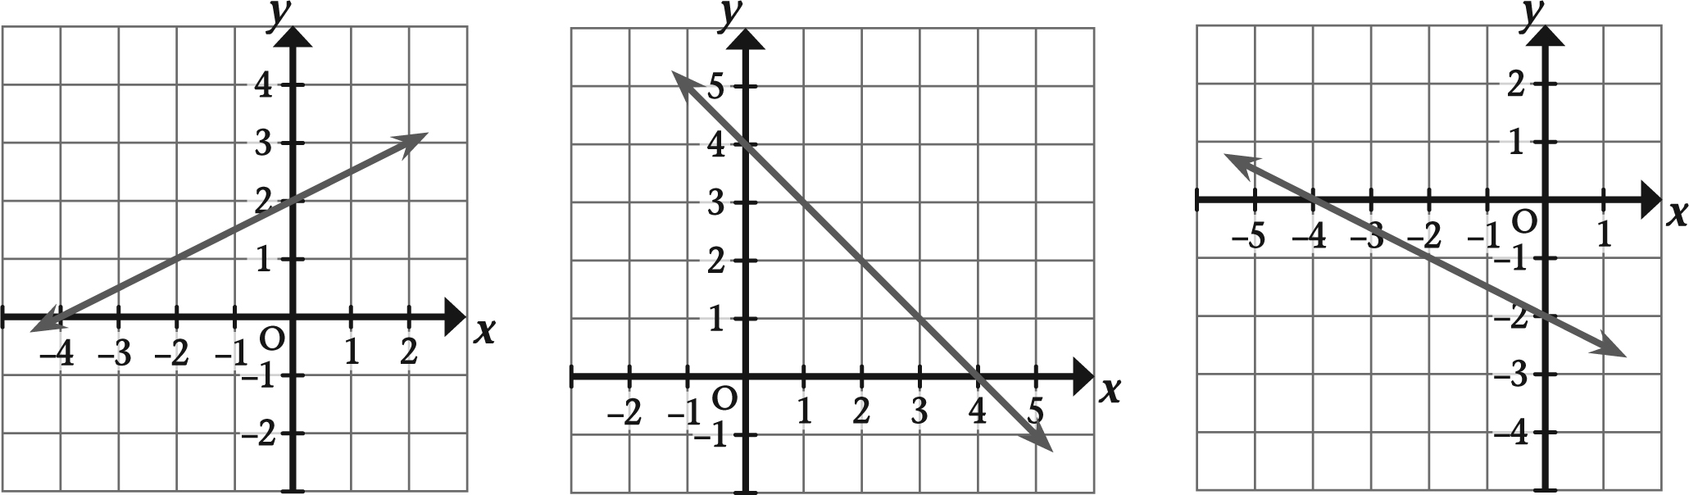
d e f

Gradient = _________ Gradient = ________ Gradient = _________
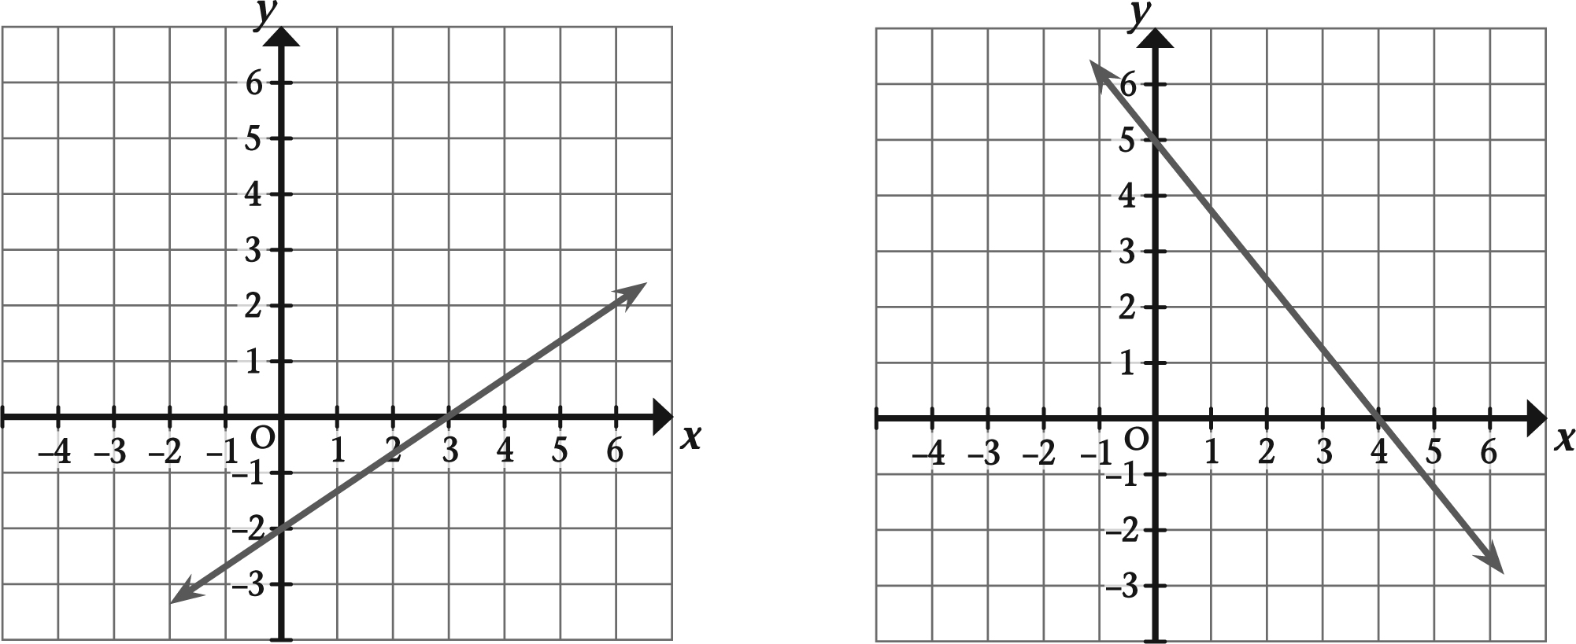
g h

Gradient = _________ Gradient = _________

